/\*\*\*\*\*\*\*\*\*\*\*\*\*\*\*\*\*\*\*\*\*\*\*\*\*\*\*\*\*\*\*\*\*\*\*\*\*\*\*\*\*\*\*

\* Programming excercise 73012 \*

\* Maxwell Stephens \*

\* 12:30 TTh \*

\* 4/20/17 \*

\*\*\*\*\*\*\*\*\*\*\*\*\*\*\*\*\*\*\*\*\*\*\*\*\*\*\*\*\*\*\*\*\*\*\*\*\*\*\*\*\*\*\*/

/\*

A program that prompts the user to enter the average rainfall for each

month of the year. Then, prompts the user to enter the actual amount of rainfall

for each month of this year. Finally, prints out a table.

\*/

#include <iomanip>

#include <iostream>

#include <fstream>

#include <string>

using namespace std;

int main() {

//declare vars

string months[12] =

{ "January", "February", "March", "April",

"May", "June", "July", "August", "September",

"October", "November", "December" };

double averageRainfall[12];

double actualRainfall[12];

//for loop to print instructions and get input

for (int i = 0; i < 12; i++) {

cout << "Enter the average monthly rainfall for " << months[i] << " in inches." << endl;

cin >> averageRainfall[i];

}

//for loop to print instructions and get input

for (int i = 0; i < 12; i++) {

cout << "Enter this year's actual rainfall for " << months[i] << " in inches." << endl;

cin >> actualRainfall[i];

}

//for loop to print input and format it

cout << left << setw(15) << "Month" << setw(25) << "Average Rainfall" << setw(30)

<< "This Year's Rainfall" << setw(10) << "Difference" << endl;

for (int i = 0; i < 12; i++) {

cout << left << setw(15) << months[i] << setw(25) << averageRainfall[i] << setw(30)

<< actualRainfall[i] << setw(10) << averageRainfall[i] - actualRainfall[i] << endl;

}

system("pause");

return 0;

}

/\*

SAMPLE OUTPUT:

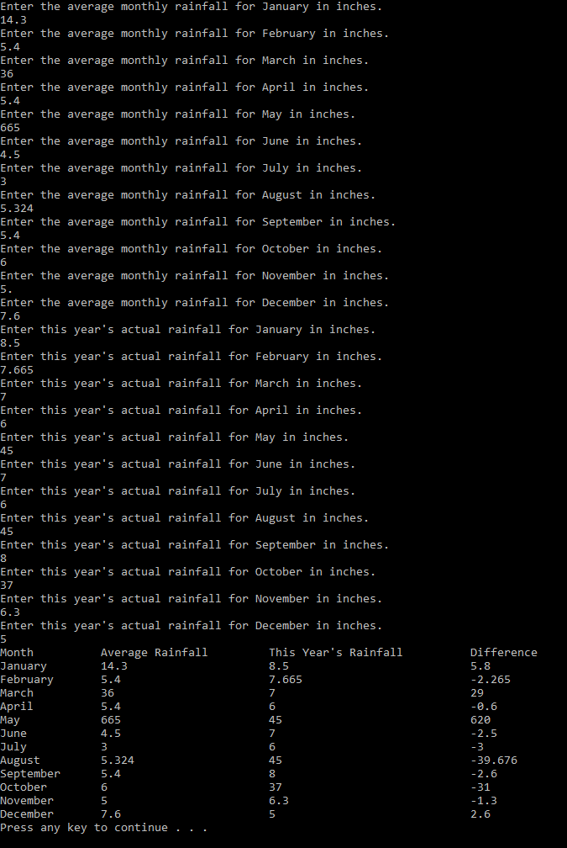

Self-Evaluation:

4: Works perfectly, code properly documented

I believe I earned 4 points.

\*/